Enfinity 2026
Team Name: normies
Theme: AI/ML

Methodology
i) Dataset Overview
Training images: 2857
Validation images: 317
Test images: 1002
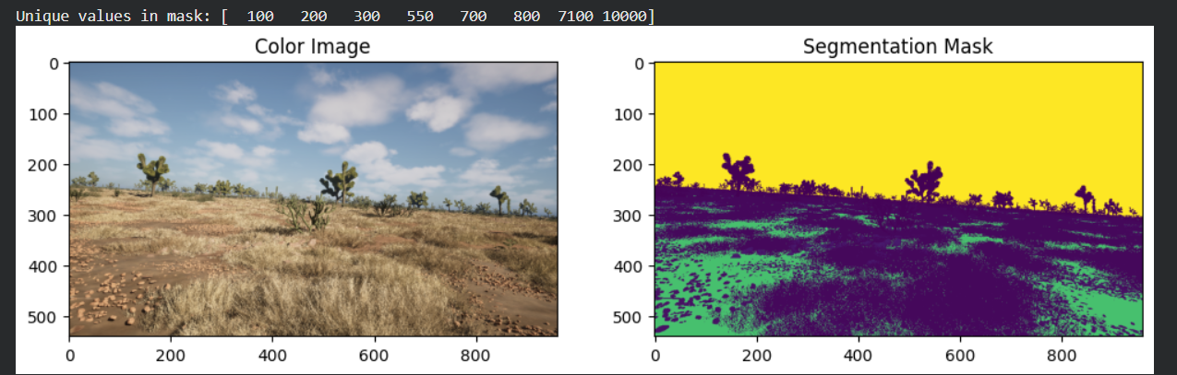

ii) Class Distribution
There are 10 classes :-
- Trees
- Lush Bushes
- Dry grass
- Dry bushes
- Ground Clutter
- Flowers
- Logs
- Rocks
- Landscape
- Sky
iii) Class Weights Used
Higher weights were assigned to rare and poorly performing classes to reduce bias toward dominant classes like Sky and Landscape.
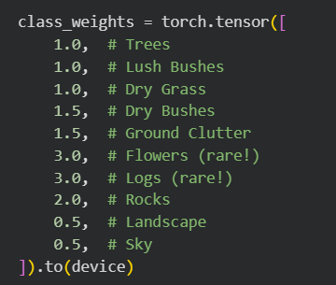

iv) Preprocessing
Segmentation masks were in uint16 format and were converted to int32 to ensure correct class label mapping during training.

v) Data Augmentation
The following augmentation methods were used:
Horizontal Flip
Random Brightness Contrast
Random Shadow
Random Sun Flare
Gaussian Blur
Color Jitter

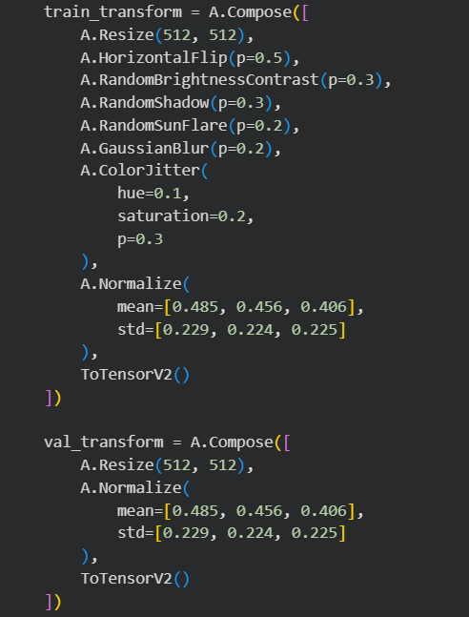
vi) Data Modelling
Parameter | Value
Model | DeepLabV3+
Encoder | ResNet50
Encoder Weights | ImageNet (Pretrained)
Optimizer | Adam
Learning Rate | 1e-4
Loss Function | Cross Entropy Loss (Weighted)
Batch Size | 8
Image Size | 512 x 512
Epochs | 25
Framework | PyTorch
Scheduler | CosineAnnealingLR

Results
Final Test Mean IoU = 0.5198
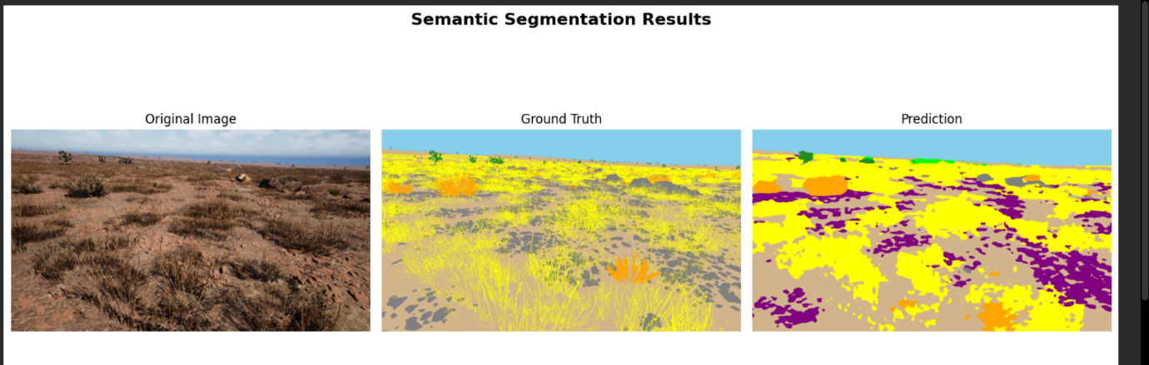
Training Loss for 25 Epochs
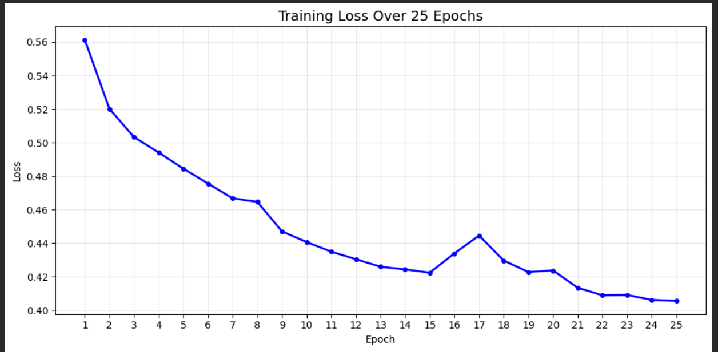

Mean IoU over 25 Epochs
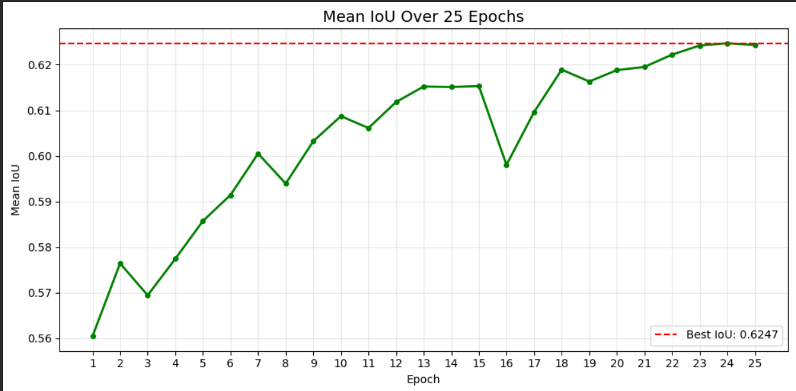
Validation per Class IoU
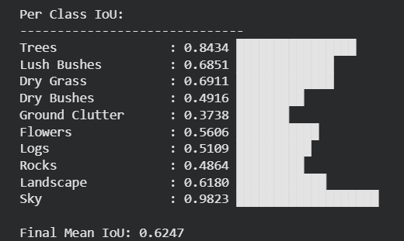

Test per Class IoU
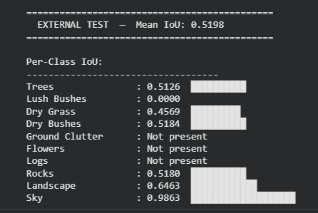

Challenges & Solutions
i) Challenge 1 - Domain Gap
Problem: The model trained on Desert A performed significantly worse on Desert B due to differences in lighting, texture, and environment - a phenomenon known as Domain Gap.
ii) Challenge 2 - Class Imbalance and Dataset Quality
Problem: Analysis of training and test masks revealed that certain classes were completely absent from the dataset. Flowers (ID 600) and Logs (ID 700) were missing from both training and test sets, making it impossible for the model to learn these classes. This is a fundamental dataset limitation affecting all teams equally.
Solution: Weighted CrossEntropyLoss was applied with higher weights for rare classes (Rocks: 2.0x, Flowers: 3.0x, Logs: 3.0x) and lower weights for dominant classes (Sky: 0.5x, Landscape: 0.5x).
iii) Challenge 3 - GPU Memory Crash During Testing
Problem: Processing all 1002 test images simultaneously caused repeated session crashes due to RAM overflow when storing all predictions in memory at once.
Solution: IoU was calculated on the fly - one image at a time with tensors deleted after each prediction. This kept memory usage constant regardless of dataset size.

iv) Model Comparison - ResNet50 vs ResNet101
We experimented with two backbone architectures. Despite ResNet101 being a deeper model, ResNet50 demonstrated better generalization on unseen test images.
DeepLabV3+ ResNet50: Val IoU = 0.6247 | Test IoU = 0.2774 (Best Model)
DeepLabV3+ ResNet101: Val IoU = 0.5754 | Test IoU = 0.2533
Analysis: The more complex ResNet101 overfit more to the training desert environment, making it less generalizable. This confirms that in domain shift scenarios, simpler models can outperform deeper ones.

Conclusion & Future Work
i) Conclusion
We successfully trained a DeepLabV3+ semantic segmentation model using transfer learning from an ImageNet pretrained ResNet50 backbone, achieving a validation IoU of 0.6247 and a test IoU of 0.5198 across 10 desert classes.
Key Findings:
1. Sky and Trees were the best performing classes with IoU of 0.98 and 0.84 respectively on the validation set.
2. Ground Clutter and Rocks were the most challenging classes due to visual similarity with the Landscape class.
3. Domain gap between training and test desert environments was the primary limiting factor, causing a drop from 0.6247 to 0.5198 in IoU.
4. Simpler ResNet50 outperformed deeper ResNet101 in cross-domain generalization, highlighting that model complexity does not always translate to better real-world performance.
5. Dataset quality limitations - specifically the absence of Flowers and Logs classes from both training and test data - posed a fundamental ceiling on achievable performance.
ii) Future Work
1. Domain Adaptation Techniques - to reduce the training to test environment gap.
2. Self-supervised Learning - for better feature extraction without relying on labeled data.
3. More Diverse Synthetic Data - generating balanced data covering all 10 classes including Flowers and Logs.
4. Higher Resolution Training - using 640x640 images for better fine detail capture in segmentation.
5. Transformer Based Models - exploring SegFormer or Mask2Former for improved segmentation performance.
6. Multi-view Detection - using multiple camera angles to improve scene understanding for UGV navigation.

